SET2:

Lab1: Reflected XSS into HTML context with nothing encoded

Task Completed:

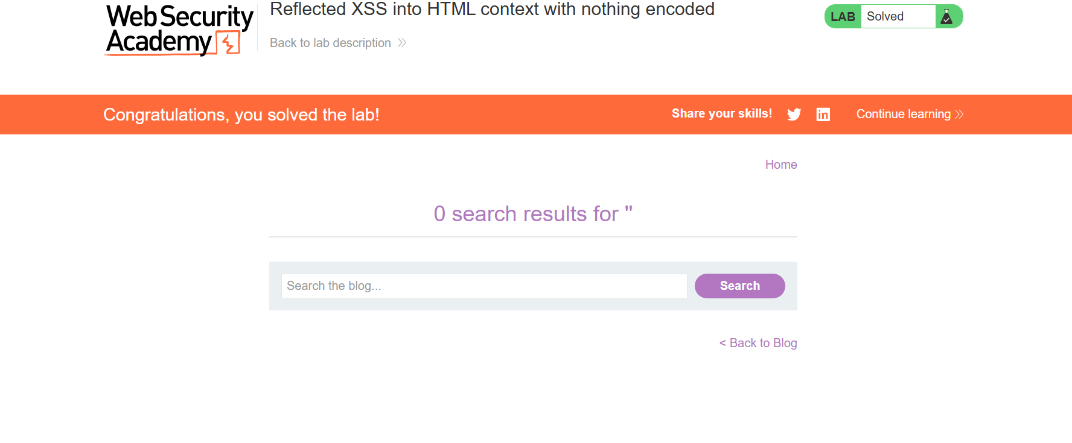

Lab2: Stored XSS into HTML context with nothing encoded

Task Completed:

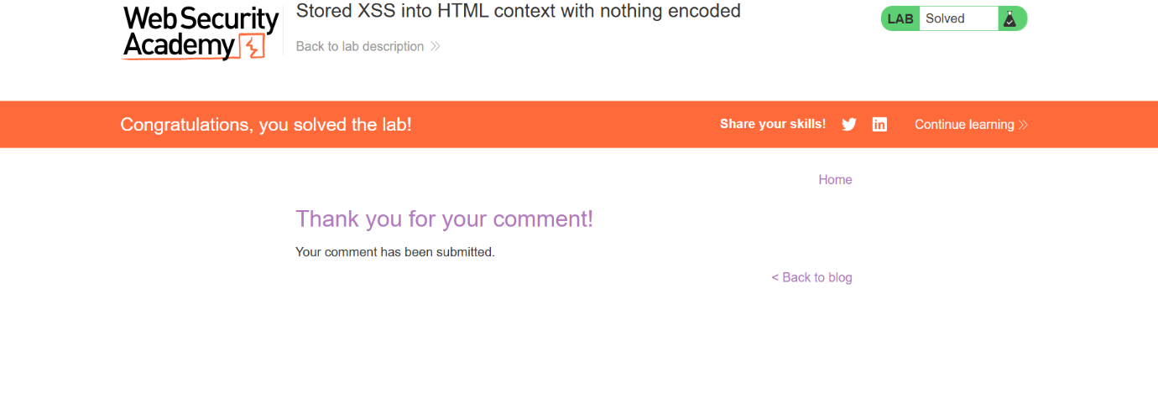

Lab3: DOM XSS in document.write sink using source location.search

Task Completed:

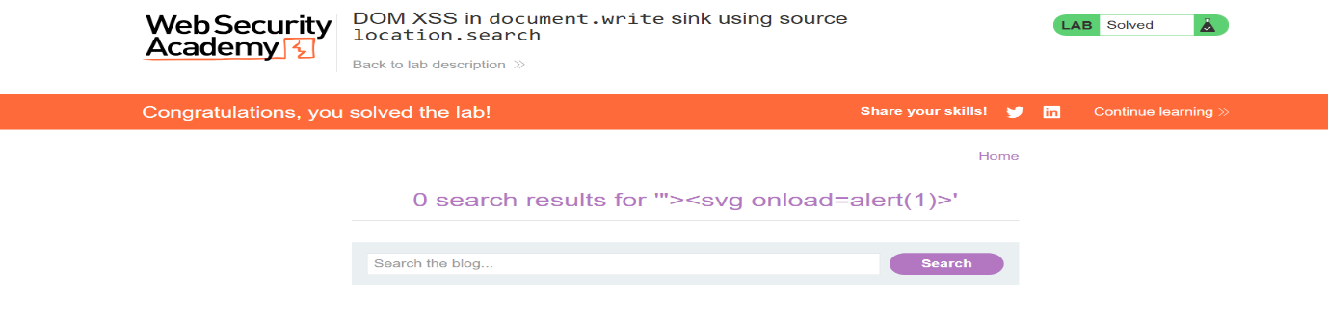

Lab 4: DOM XSS in document. write sink using source location. search inside a select element

Task Completed:

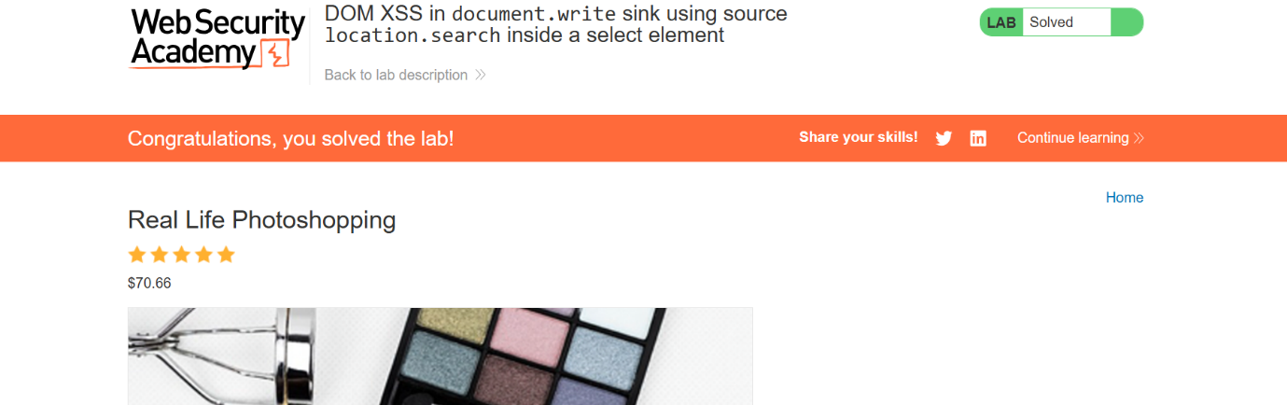

Lab 5: DOM XSS in innerHTML sink using source location. Search

Task Completed:

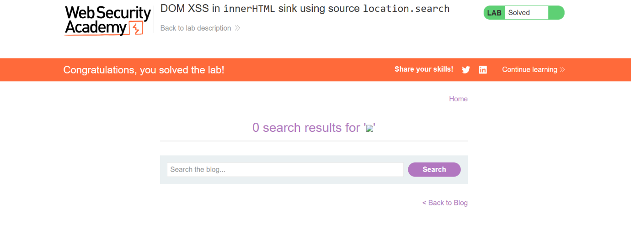

Lab 6: DOM XSS in jQuery anchor href attribute sink using location. search source

Task Completed:

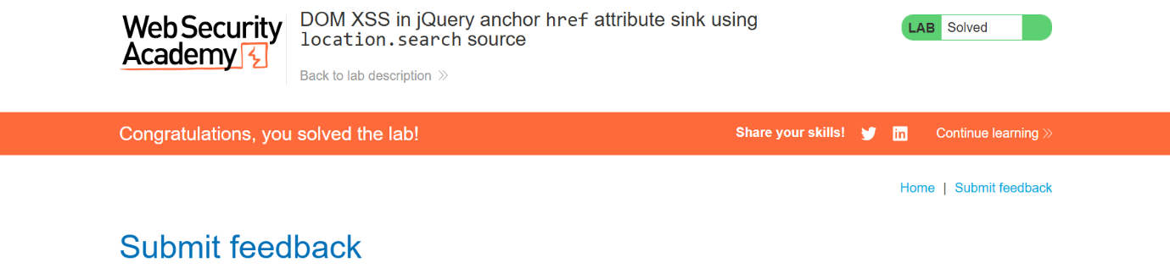

Lab 7: DOM XSS in AngularJS expression with angle brackets and double

Task Completed:

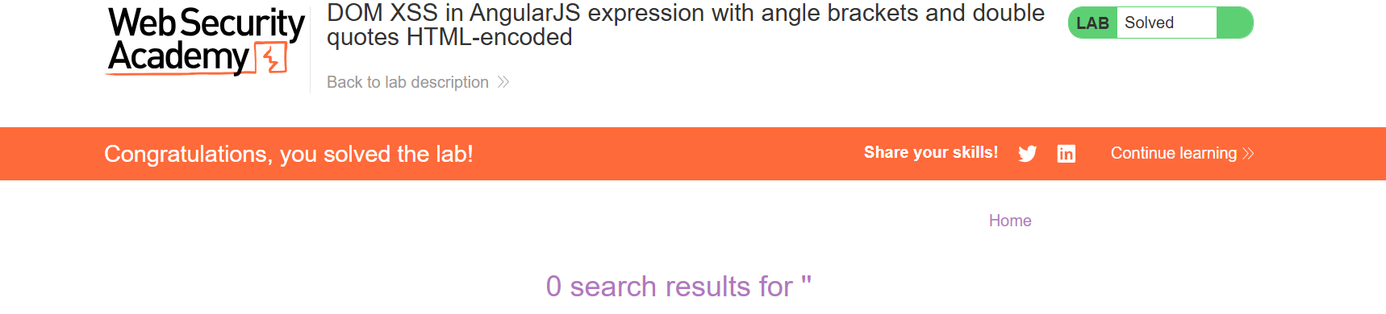

Lab 8: Stored DOM XSS

Task Completed:

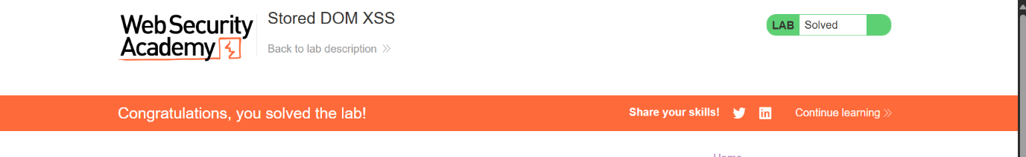

Lab 9: Reflected XSS in canonical link tagTask Completed:

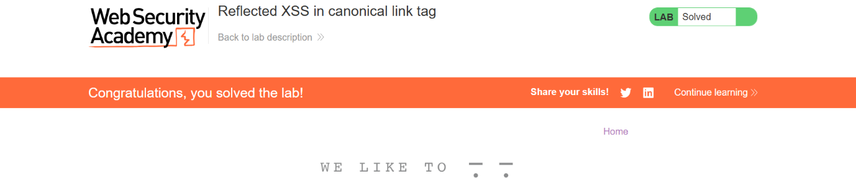

Lab 10: Reflected XSS into a template literal with angle brackets, single,double quotes, backslash and backticks Unicode-escaped

Task Completed:

